♂
“Just as open-source application are built out of separately authored modules, the Web makes it possible to have mobspots, political advertising created by a crowd.”
From Internet-Era Democracy, Can the World Wide Web give ordinary people a shot at true populism?
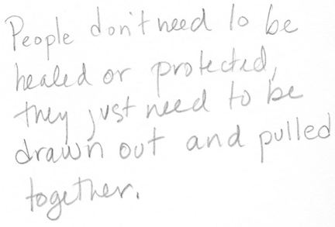

21. Fortune (Conception)—Track 25 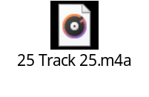

“In other centuries, human beings wanted to be saved, or improved, or freed, or educated. But in our century, they want to be entertained. The great fear is not of disease of death, but of boredom. A sense of time on our hands, a sense of nothing to do. A sense that we are not amused.
“This artifice will drive them to seek authenticity. Authenticity will be the buzzword of the twenty-first century. And what is authentic? Anything that is not devised and structured to make a profit. Anything that is not controlled by corporations. Anything that exists for its own sake, that assumes its own shape. But of course, nothing in the modern world is allowed to assume its own shape. The modern world is the corporate equivalent of a formal garden, where everything is planted and arranged for effect. Where nothing is untouched, where nothing is authentic.
“Where, then, will people turn for the rare and desirable experience of authenticity? They will turn to the past.

“The past is unarguably authentic. … The past is real. It’s authentic. And this will make the past unbelievably attractive. That’s why I say that the future is the past. …”

